**DAILY ONLINE ACTIVITIES SUMMARY**

|  |  |  |  |  |  |  |  |  |
| --- | --- | --- | --- | --- | --- | --- | --- | --- |
| **Date:** | **22-05-2020** | | | | | **Name:** | **Rohan Mahaveer** | |
| **Sem & Sec** | **6th B** | | | | | **USN:** | **4AL17CS077** | |
| **Online Test Summary** | | | | | | | | |
| **Subject** | | **Operation Research(OR)** | | | | | | |
| **Max. Marks** | | **30** | | **Score** | | | **30** | |
| **Certification Course Summary** | | | | | | | | |
| **Course** | **Ethical Hacking** | | | | | | | |
| **Certificate Provider** | | | **Alison** | | **Duration** | | | **6hrs** |
| **Coding Challenges** | | | | | | | | |
| Problem Statement: 1. Write a C Program to implement various operations of Singly Linked List Stack  2. Write a Java Program to find the largest and smallest word in a string. | | | | | | | | |
| **Status:** YES, Completed all Programs | | | | | | | | |
| **Uploaded the report in Github** | | | | | **YES** | | | |
| **If yes Repository name** | | | | | <https://github.com/rohanmahaveer/daily-status> | | | |
| **Uploaded the report in slack** | | | | | **YES** | | | |

Online Test Details:

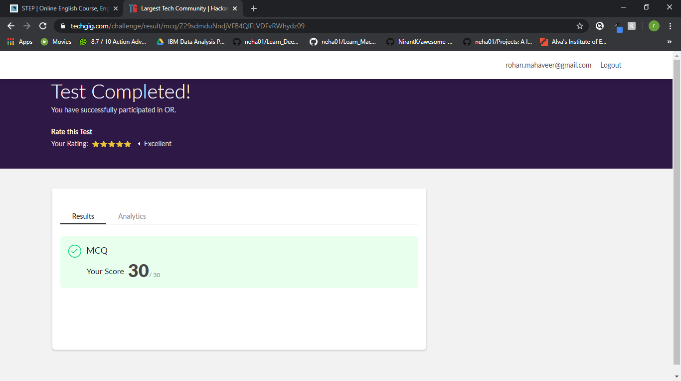

Scored 30 out of 30 in OR 1st I.A test

Certification Course Details:

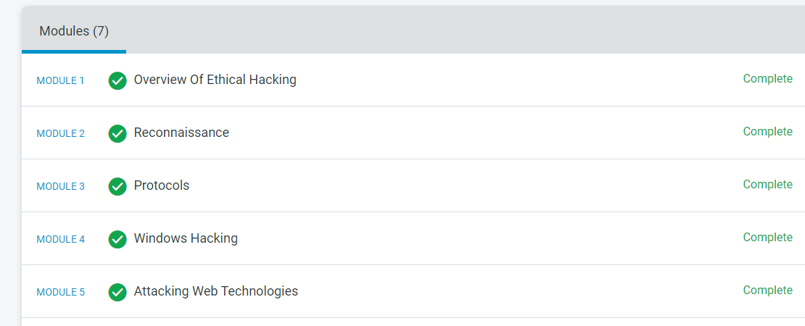

The above course is being taken up by me is based on Ethical hacking. It started with the CIA triad, today in online course I studied about SQL injection, misconfiguration software, broken authentication and how to prevent this types of attack. The details of the course and certificate provider are mentioned in the above form.

Coding Challenges Details:

Program1:

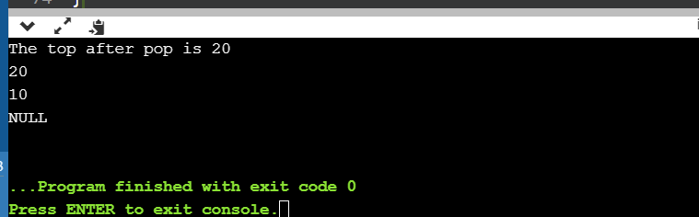

Program2:

